**Fanka Shundovska**

**IntelliJ – End-To-End Selenium Homework**

* Create new project with all necessary dependencies and we will use the following website: https://www.saucedemo.com/
* Your task will be to create one End-to-End test using the POM. The flow should be as follows:

1. Log in to the page with credentials standard_user/secret_sauce.
2. Add products to the cart.
3. Navigate to the cart and click the checkout button.
4. Enter Checkout information(First name, Last Name, ZIP) and click continue.
5. Click on Finish Button.
6. Assert that the “Thank you for your order” text is displayed.

**Note**: Upload the homework as a zip file (Exported Intellij project: File -> Export -> Project to zip file)

**Login Page:**

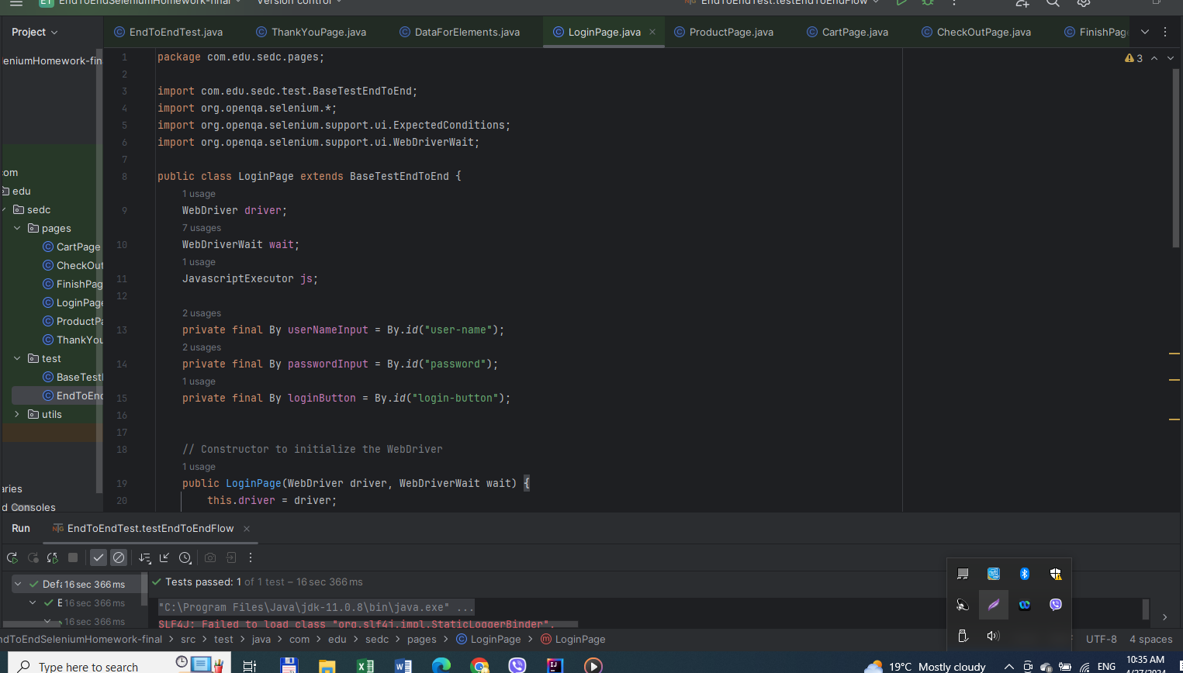

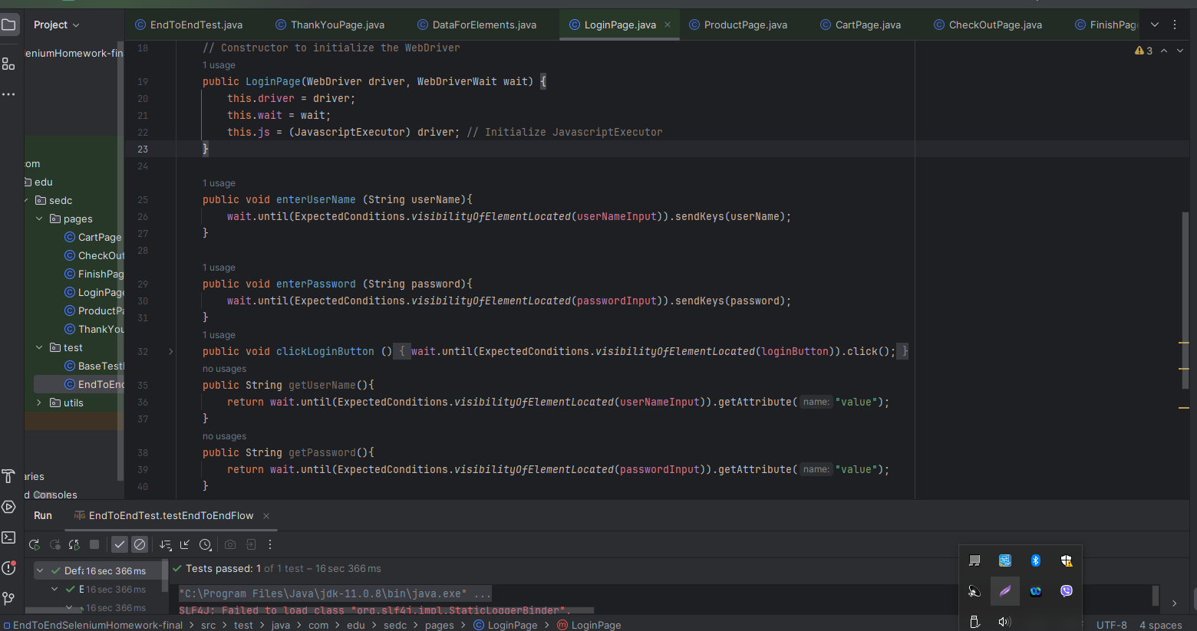

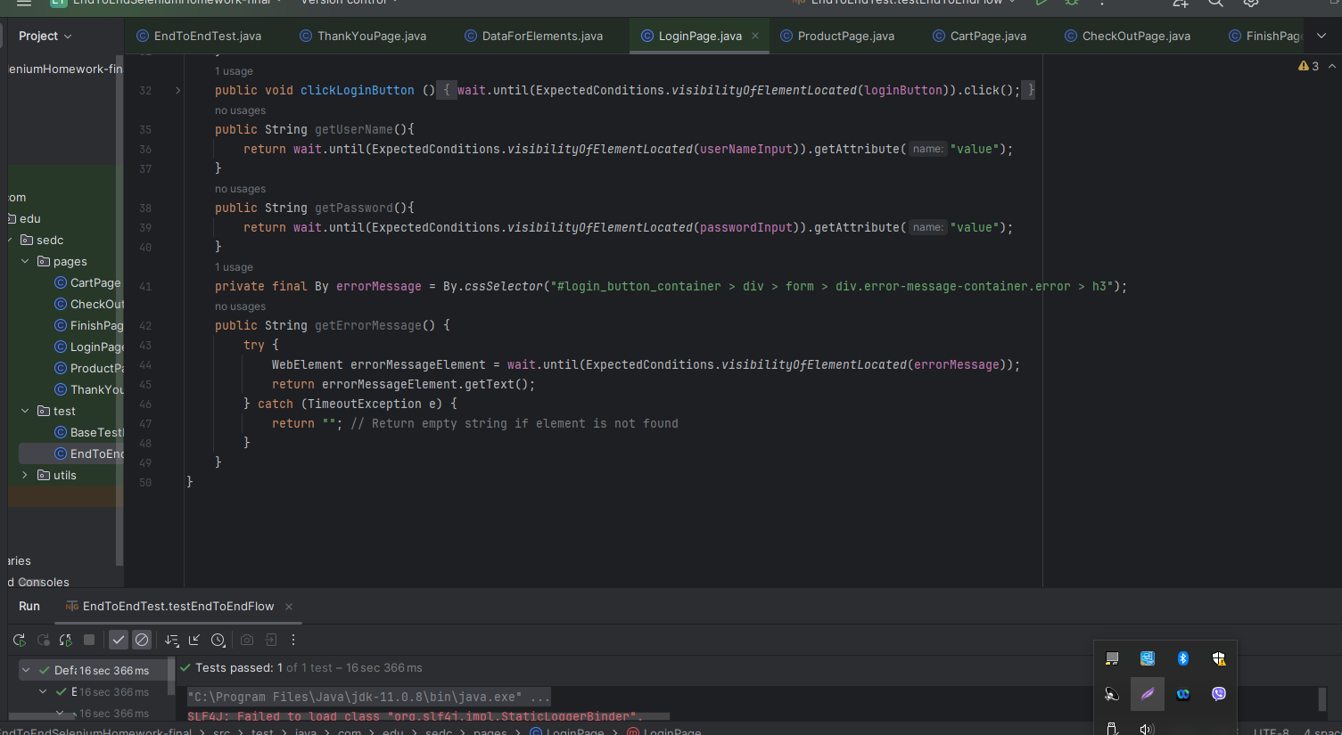

**ProductPage:**

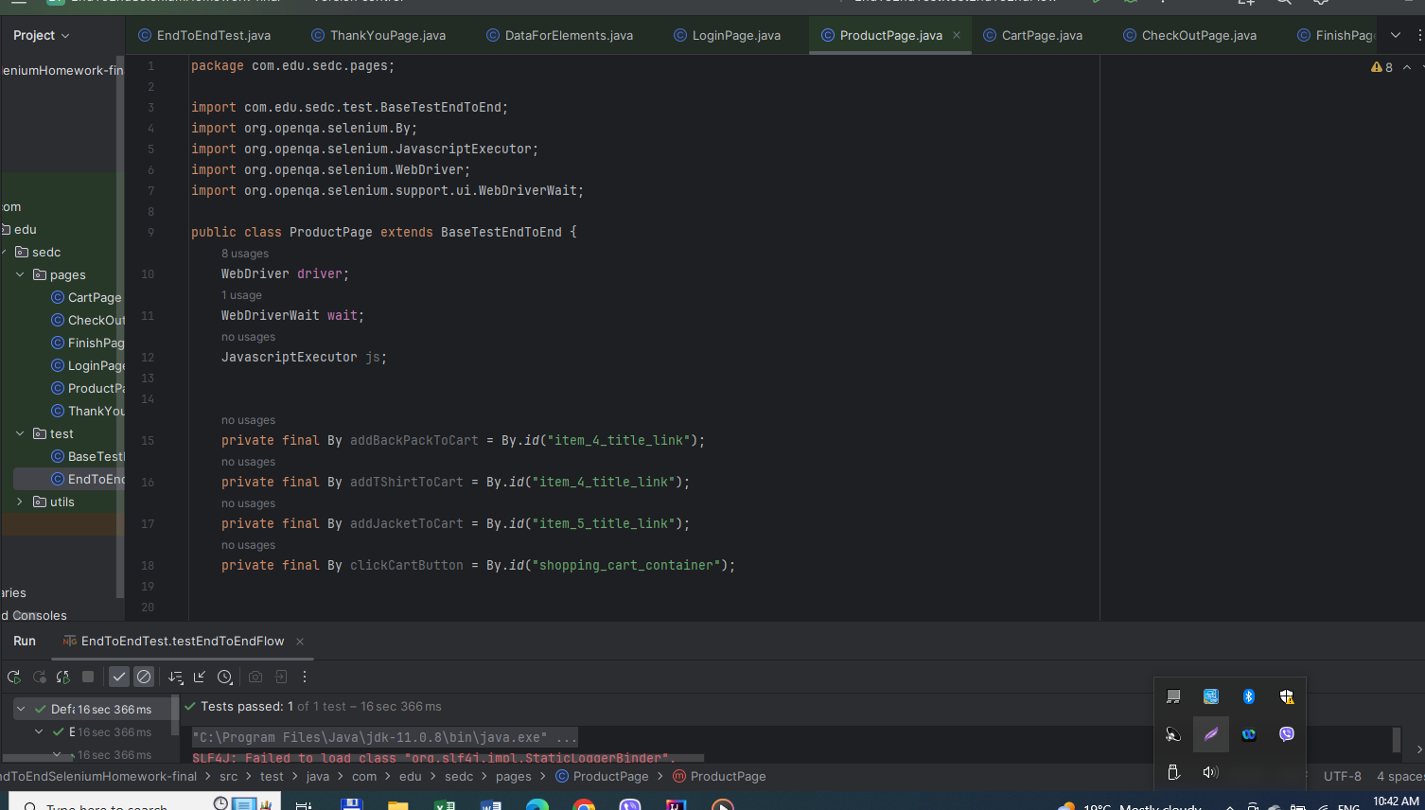

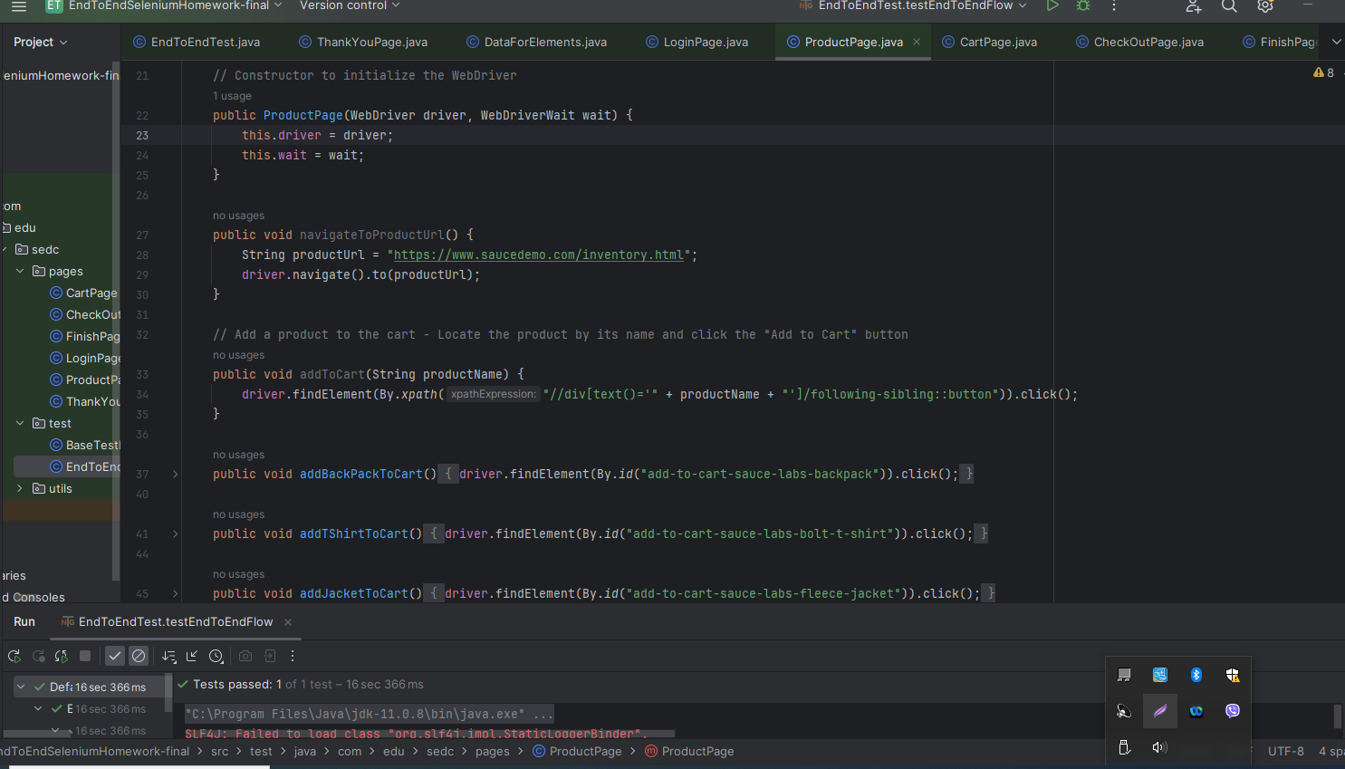

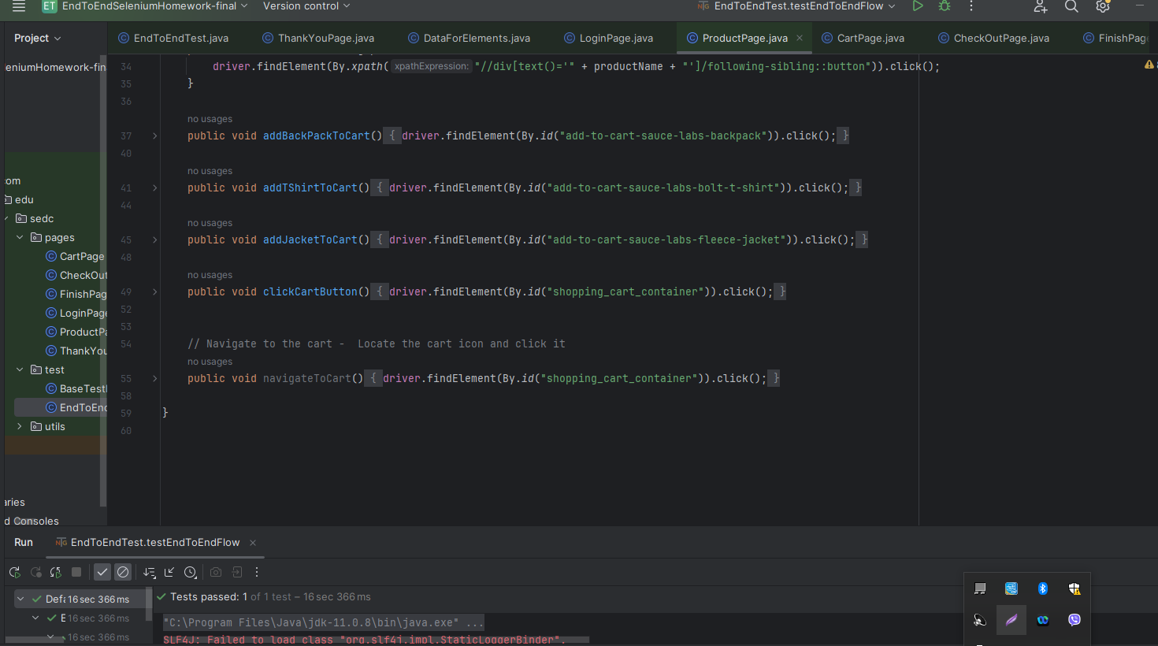

**Cart Page**:

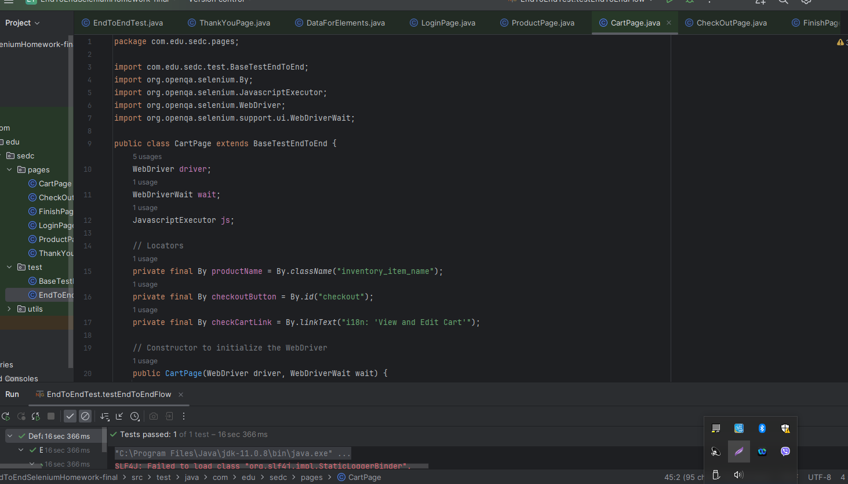

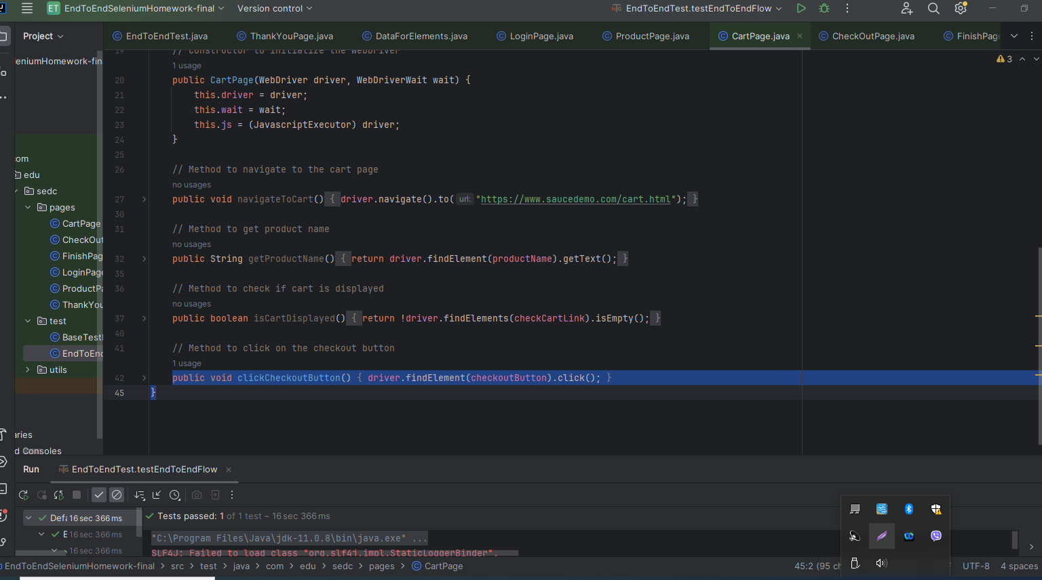

**Check Out Page:**

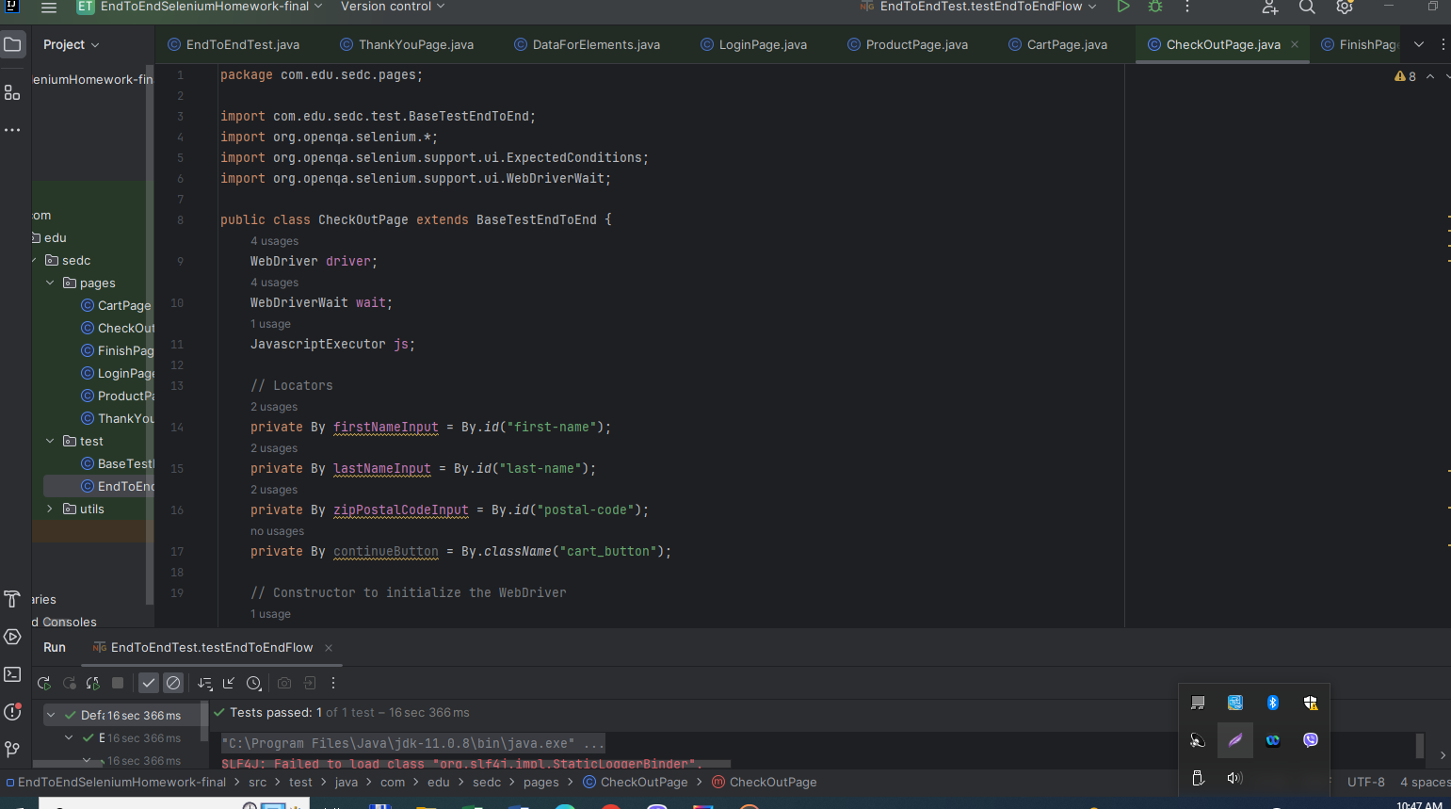

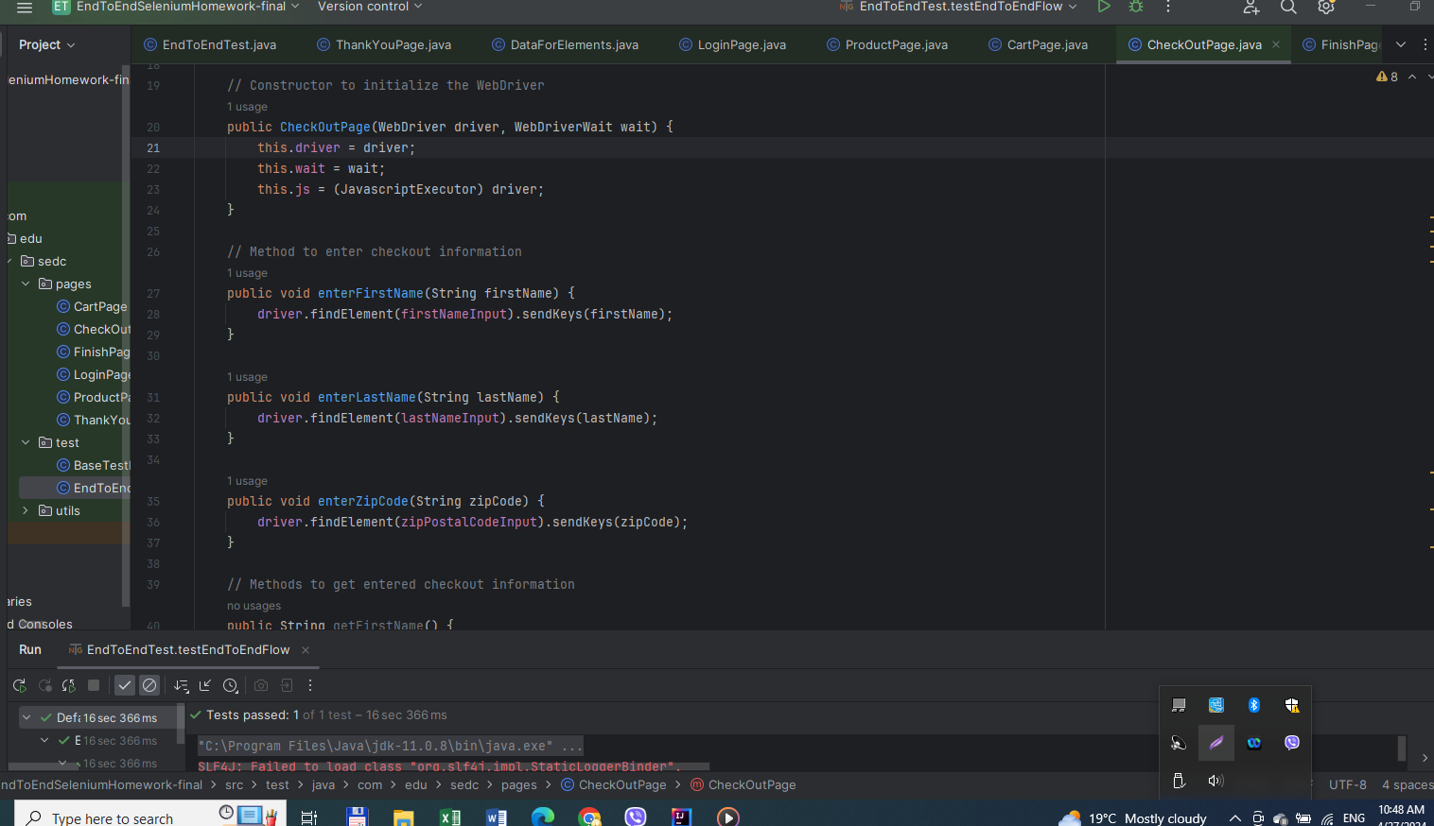

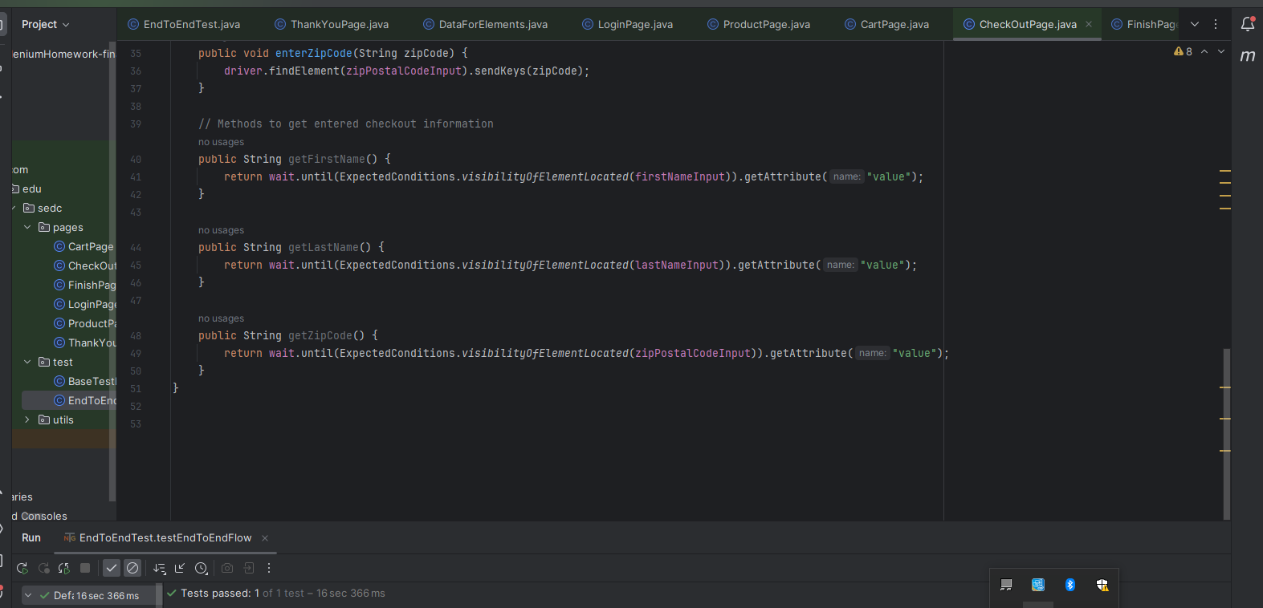

**Finish Page:**

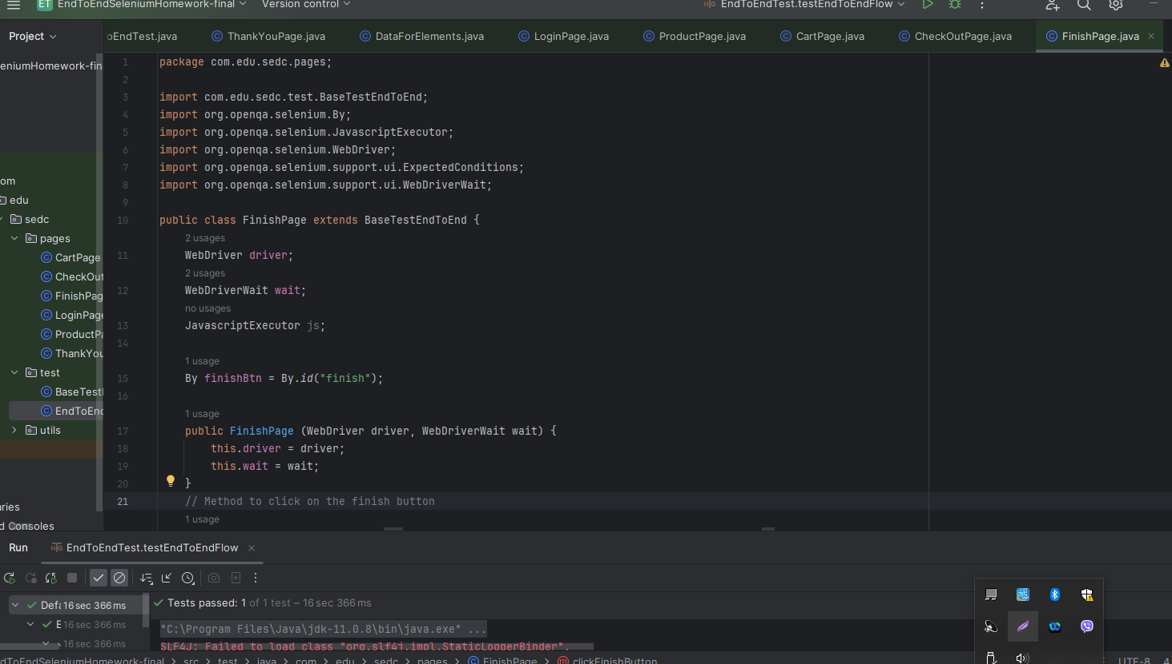

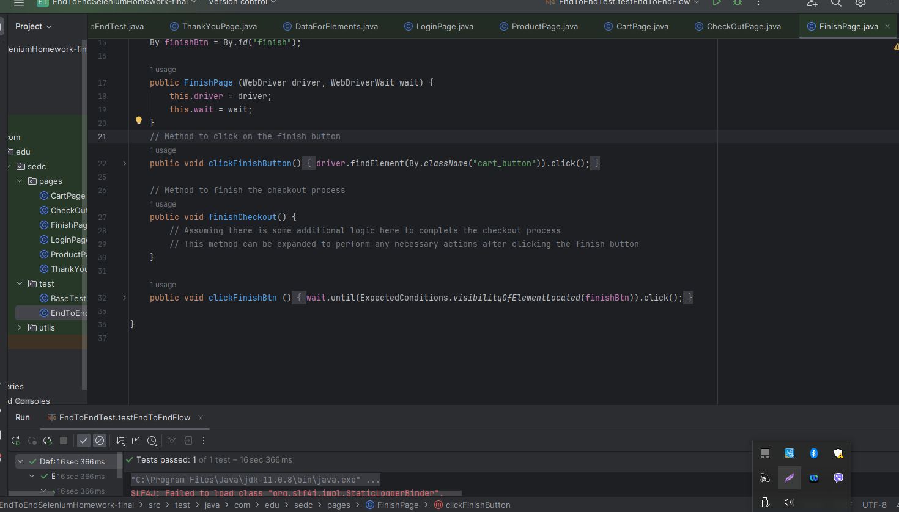

**Thank You Page:**

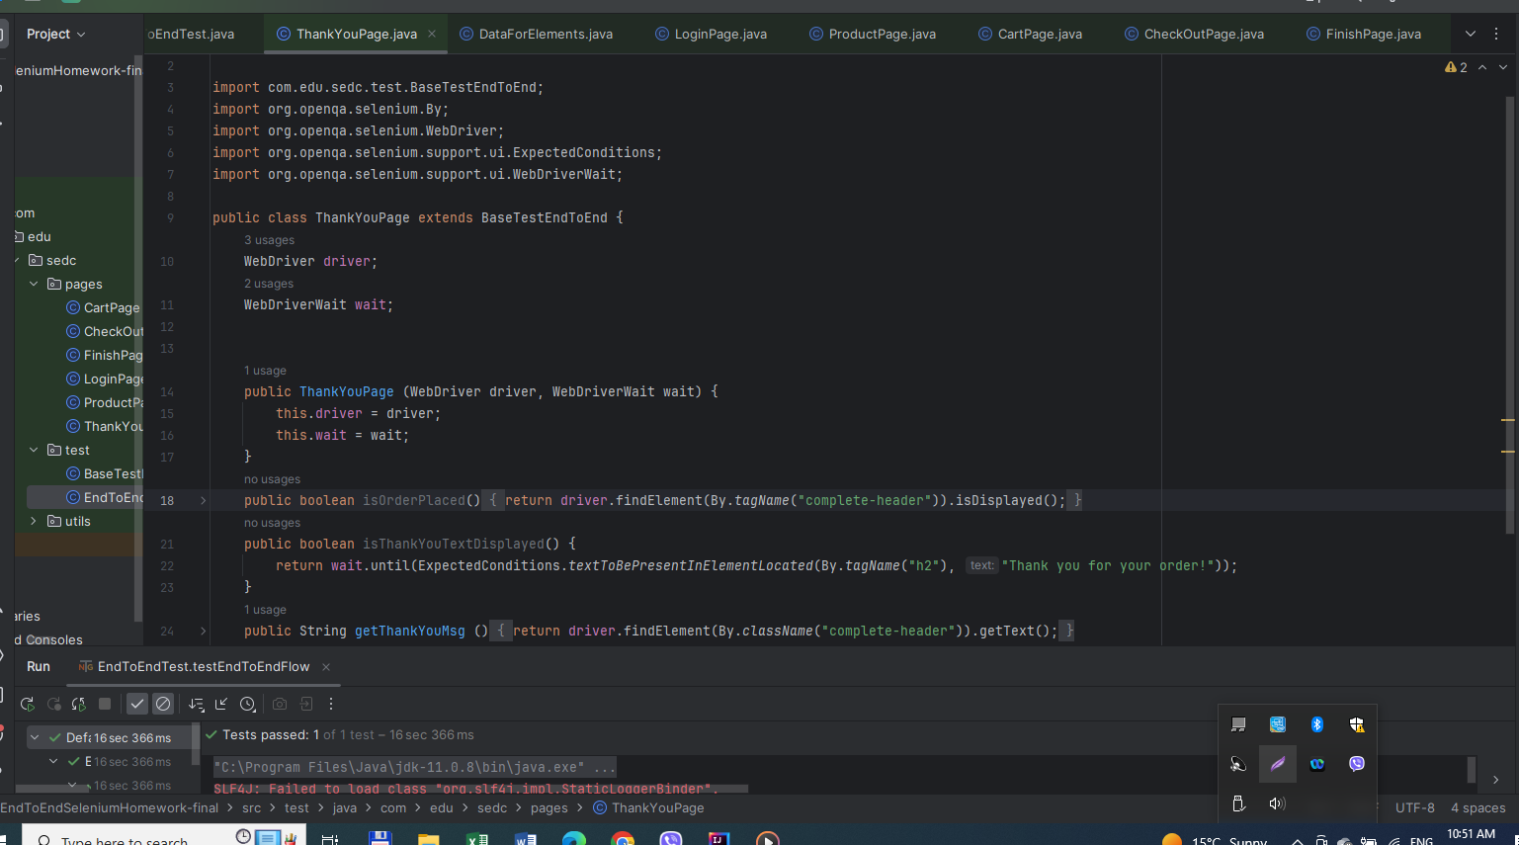

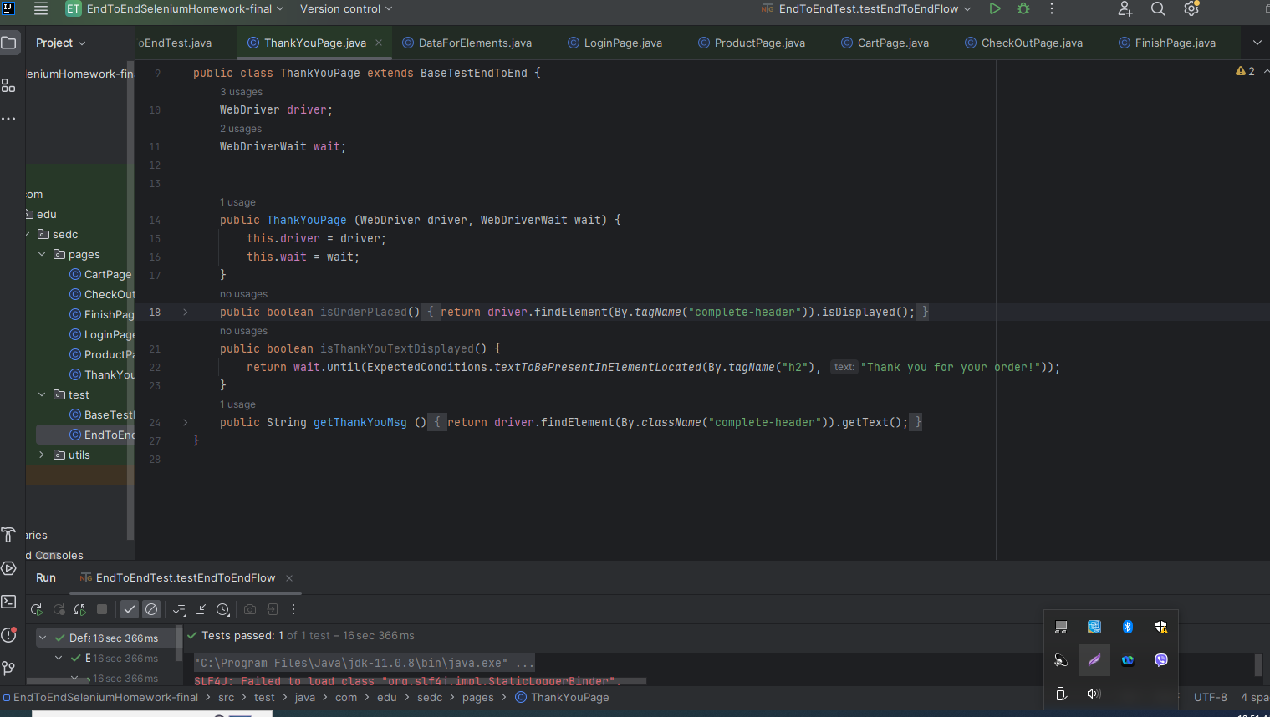

**Base Test:**

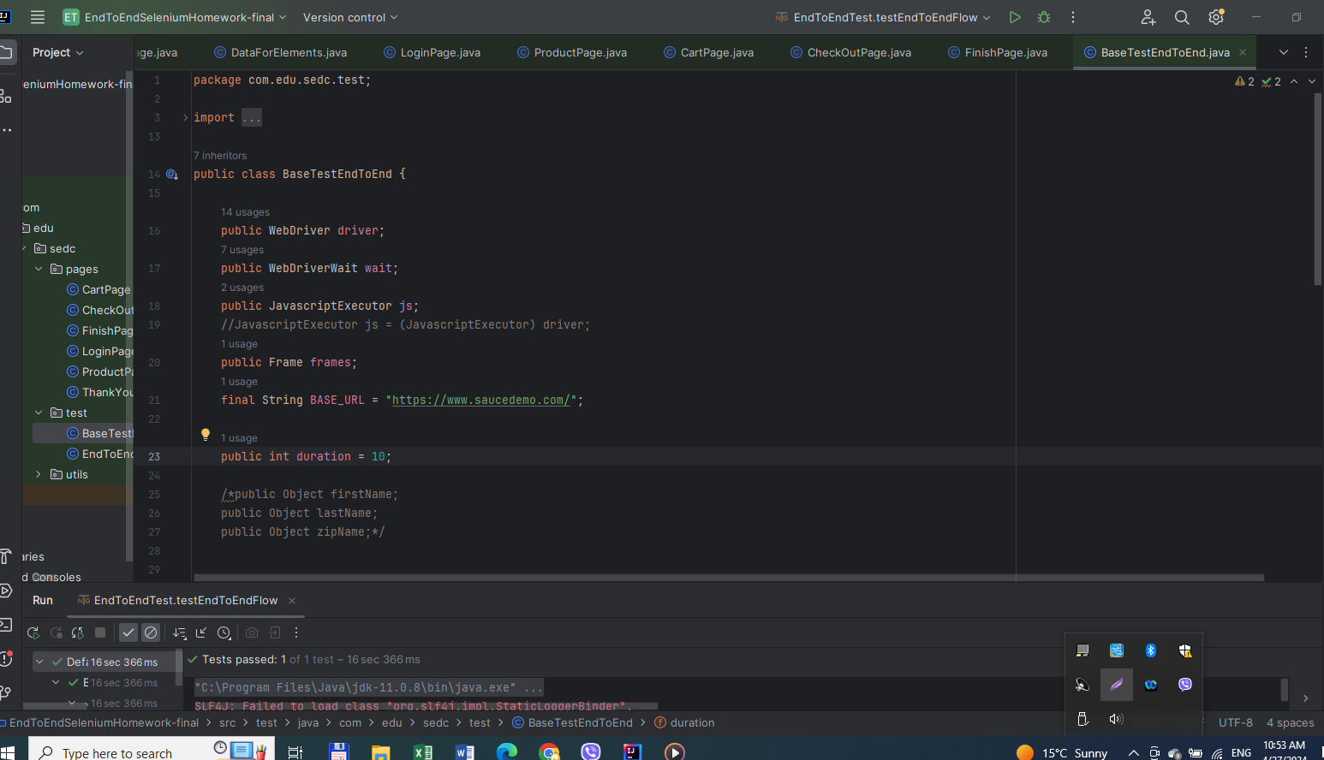

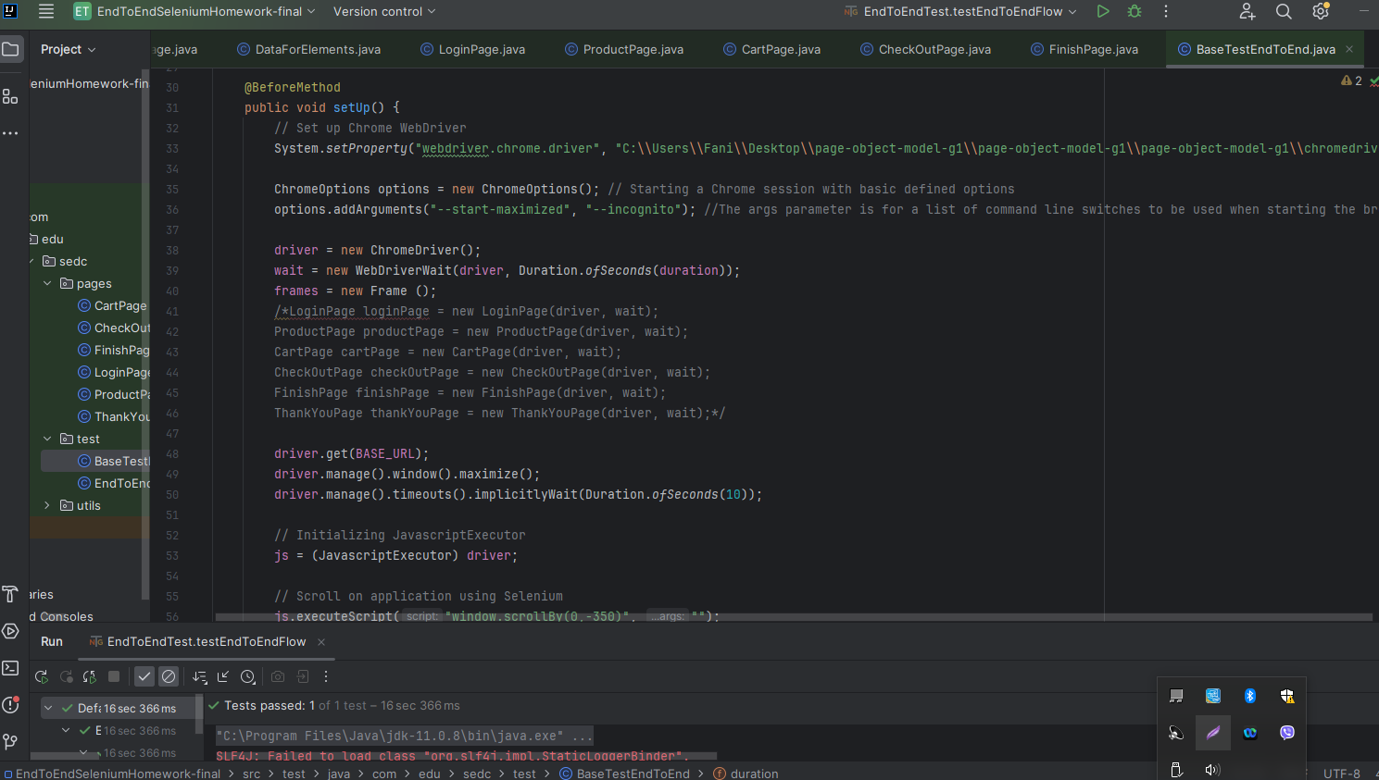

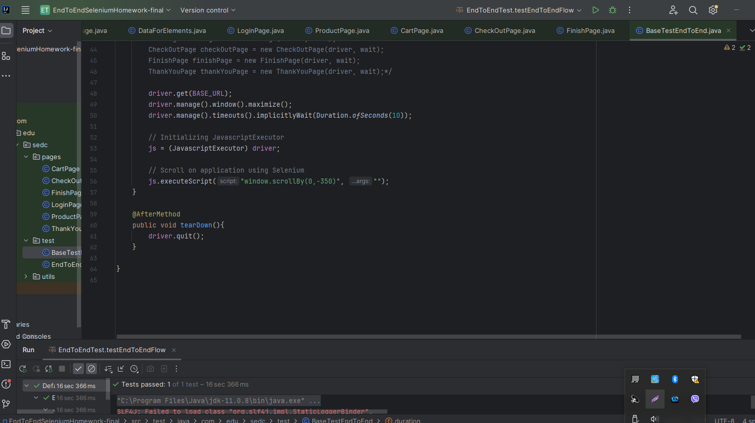

**Data For Elements:**

